- Launch one EC2 instance using Amazon Linux 2.
login in AWS console search for EC2 And click on Instances, Launch instance Give a name or tag and click on amazon Linux AWS select architecture 64-bit(*84), select instance type t3 micro and create a new pair key ,select no. of instances as click on launch instance, instance launched successfully. click on running instances and click on connect
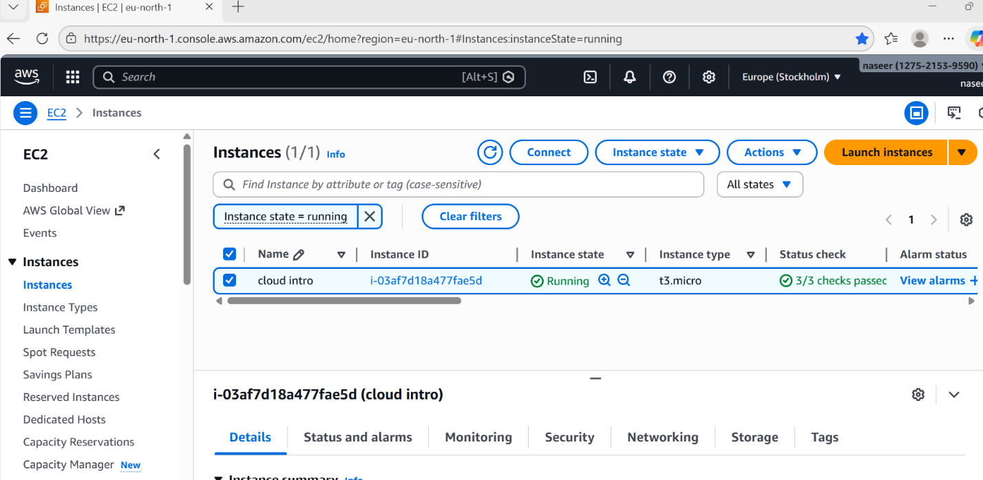
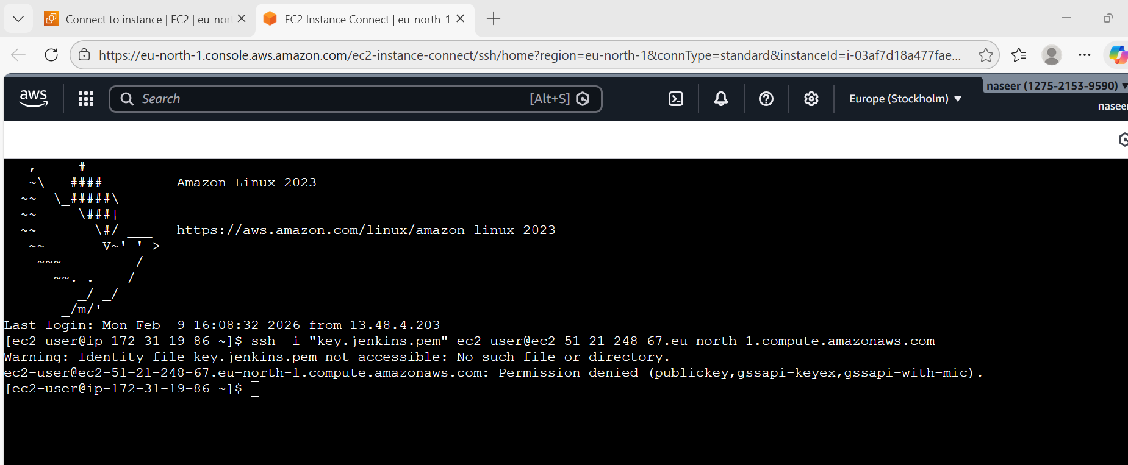

2. Install Docker.
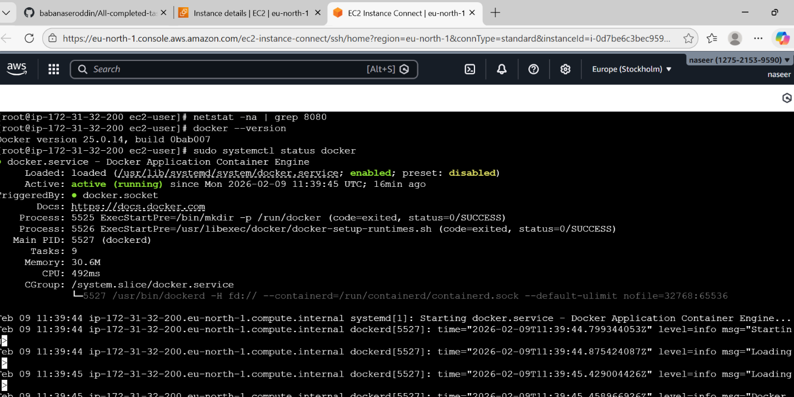
3. Install Jenkins.
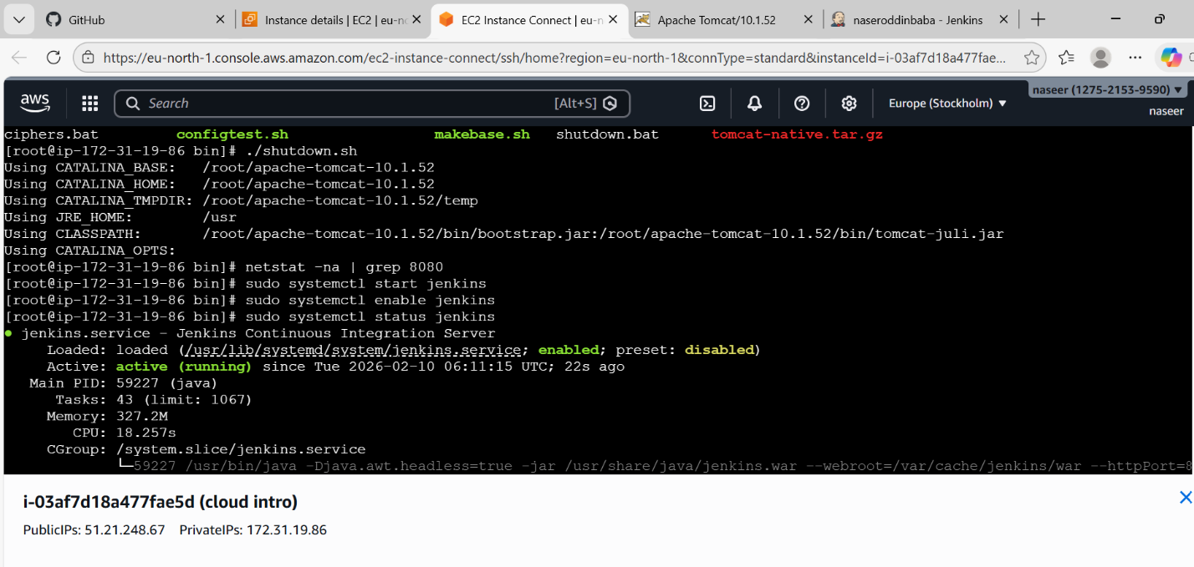
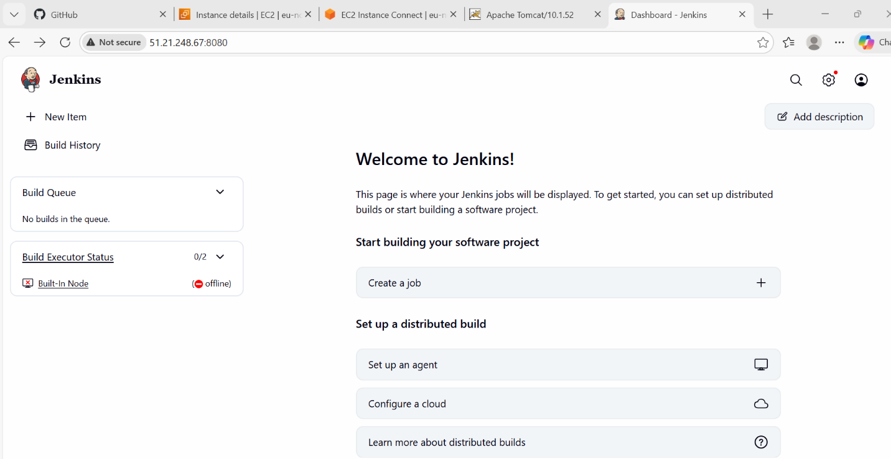
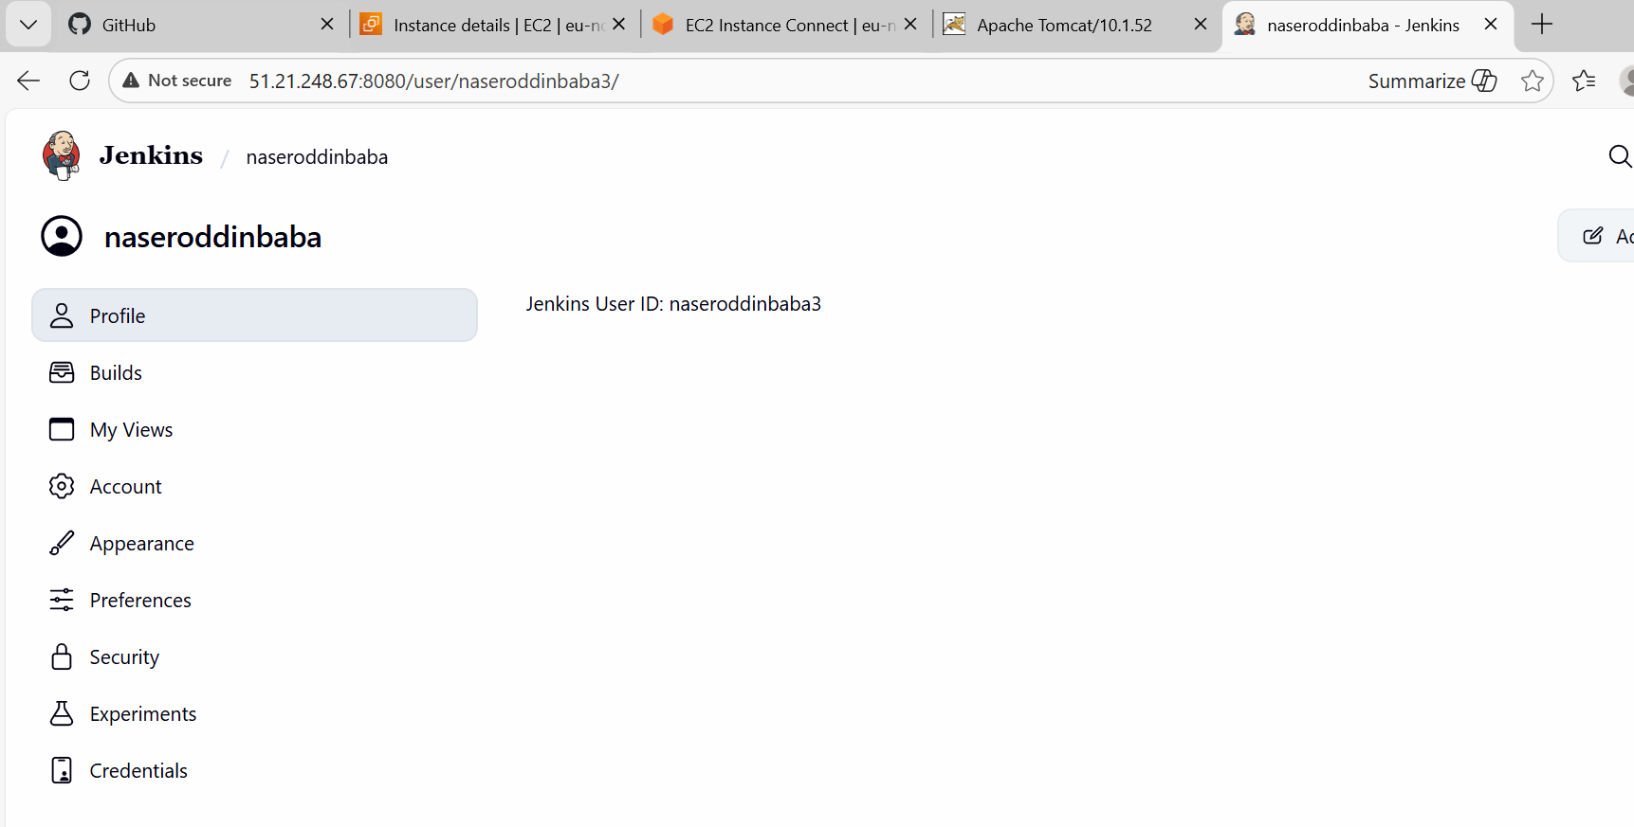

4. Install Apache.
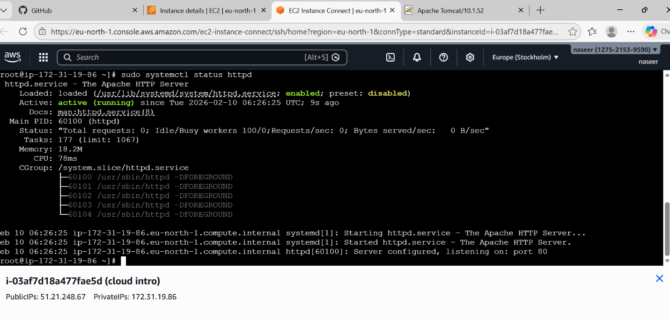
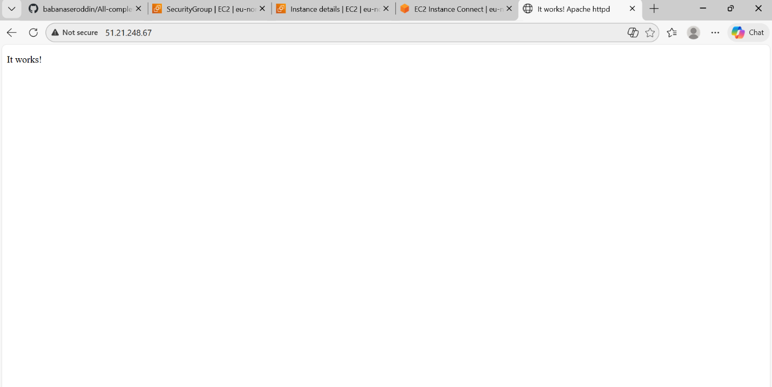

5. Install Nginx.
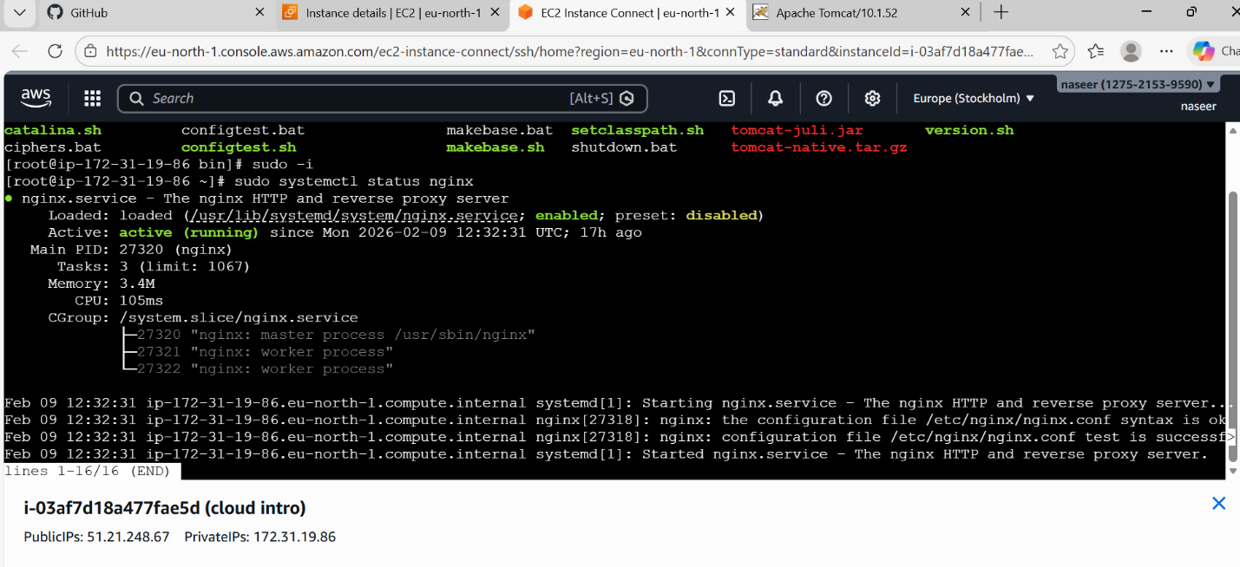
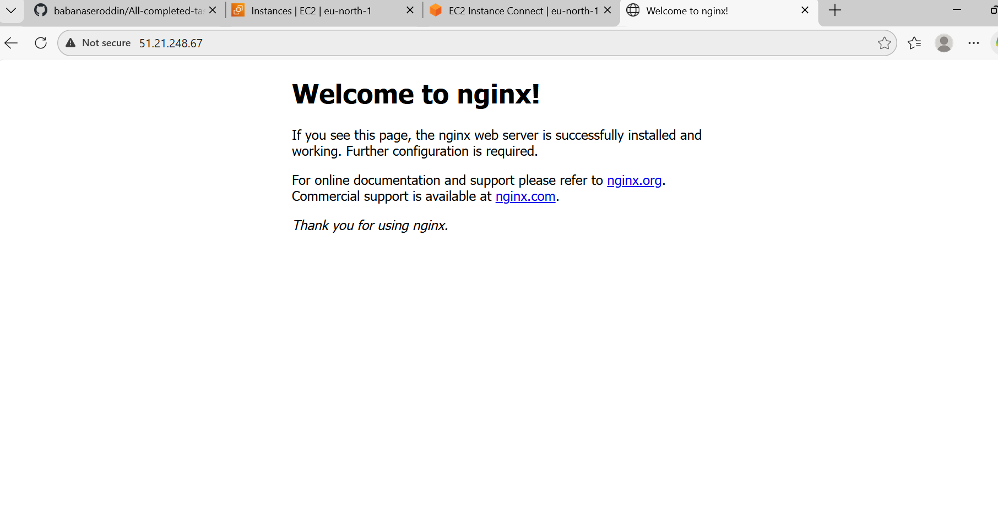

6. Install Apache Tomcat.
